**Ibe's Heavenly Huevos Rancheros**

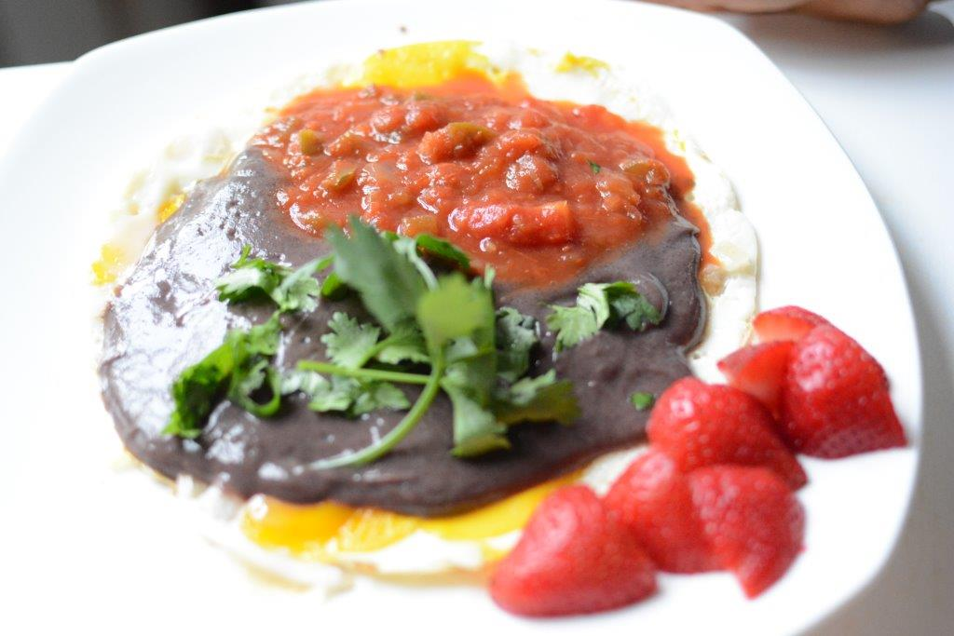

Prep Time: 5 minutes

Cooking Time: 5 minutes

1 serving

**Ingredients**

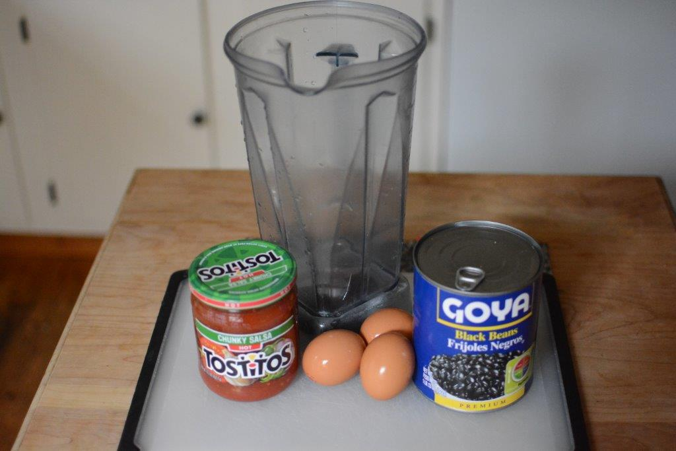

½ can black or pinto beans (rinsed and drained) OR refried beans

Cooking spray or olive oil

3 eggs

¼ cup salsa

1 tablespoon onions, chopped, for garnish

1 tablespoon cilantro, chopped, for garnish

¼ cup low-fat cheddar cheese, shredded or reduced-fat feta cheese, crumbled (optional)

**Directions**

1. Warm beans (purchase refried or blend pinto or black beans in the blender) on the skillet

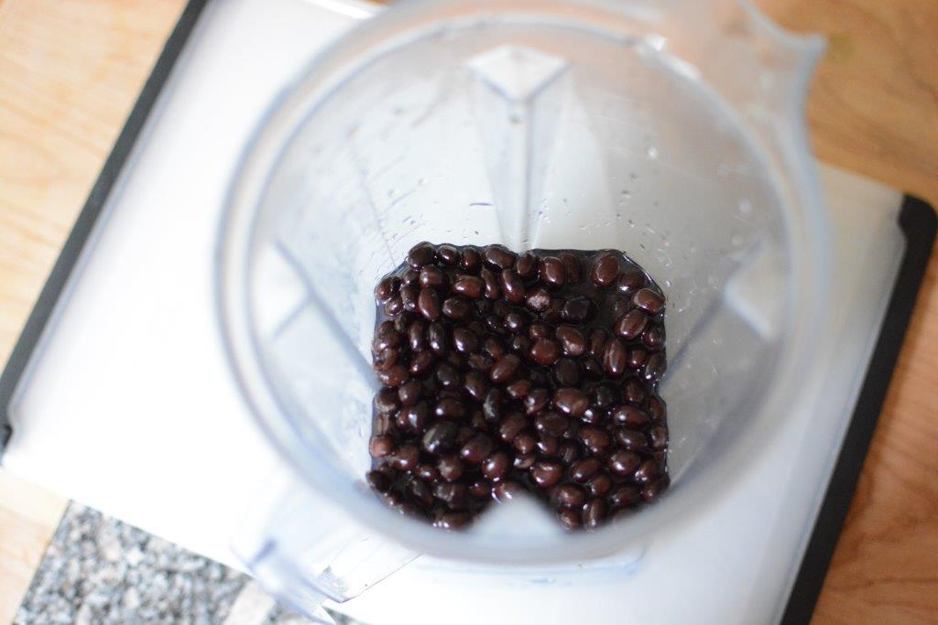Blending canned rinsed beans

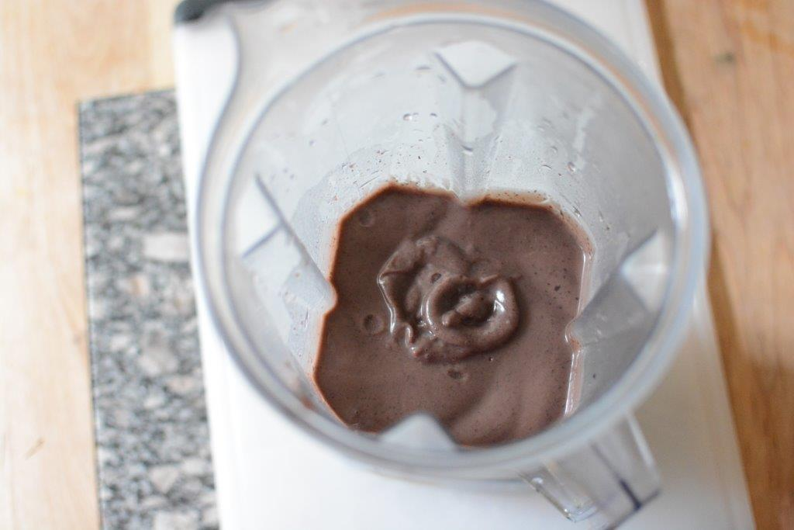

2. Using 2 egg whites and 1 egg, make a fried egg with cooking spray or a touch of olive oil on a separate skillet



3. On a plate, layer eggs, beans, and salsa/hot sauce

4. Sprinkle fresh onions, cilantro, and low-fat cheddar or feta cheese (optional) on top. Serve with a ½ cup of strawberries or other berries.

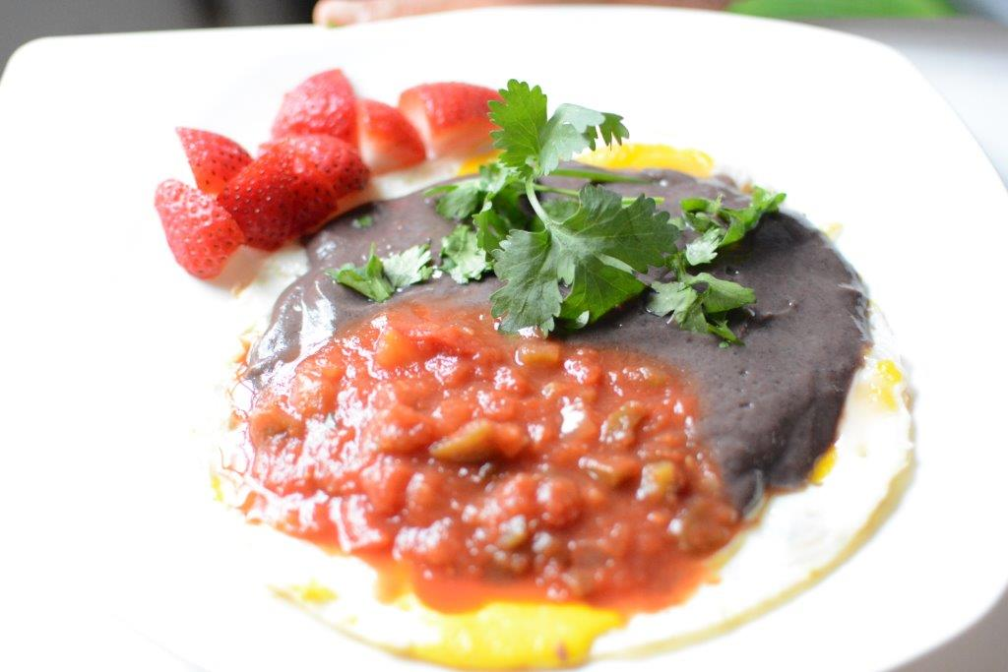

Have a fabulous, high-energy weekend!